**LAB#12**

Design user interface screens for Event Management App or Web using various interactive devices.

You are required to design interaction screens, using interactive devices that should clearly indicate advantages of interactive devices.

The conclusion should include answers of the questions:

1. Any specific interactive devices used to make the applications usable for

a) People with difficulty using keyboard

b) People with visual disability

c) People who are more than 45 years old.

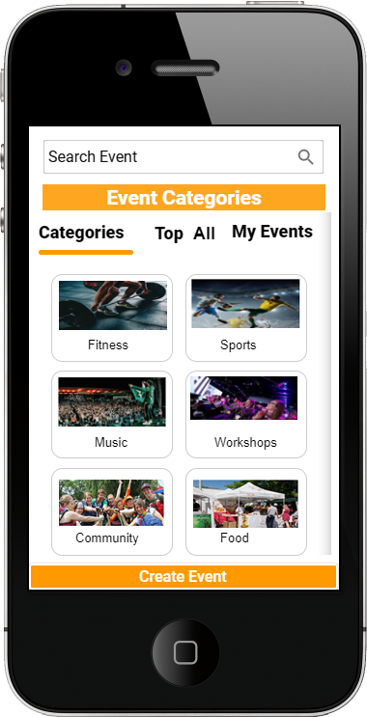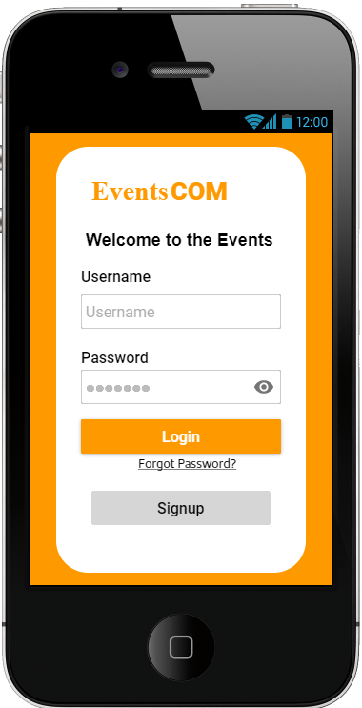 **1 2**

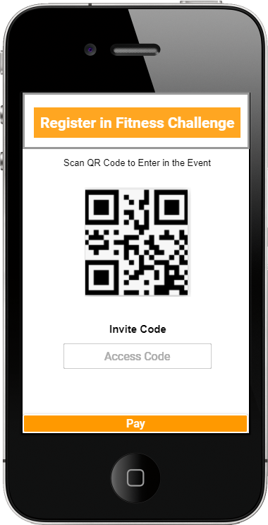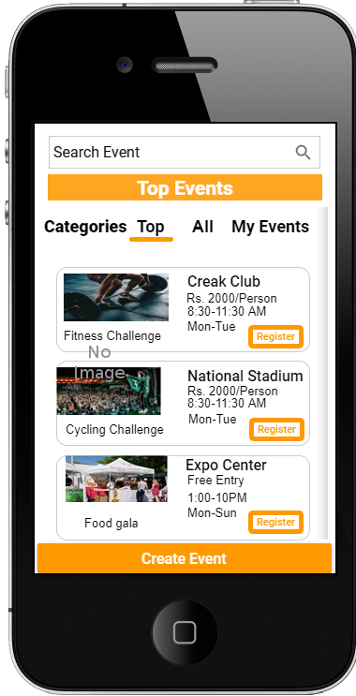 **3 4**

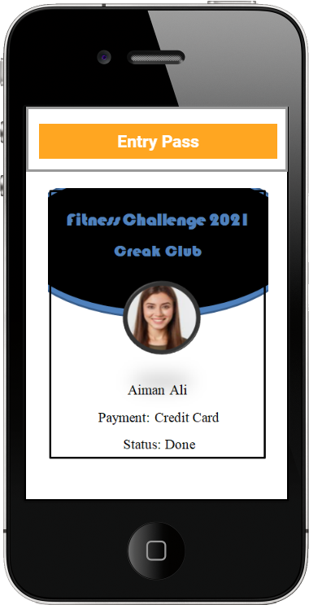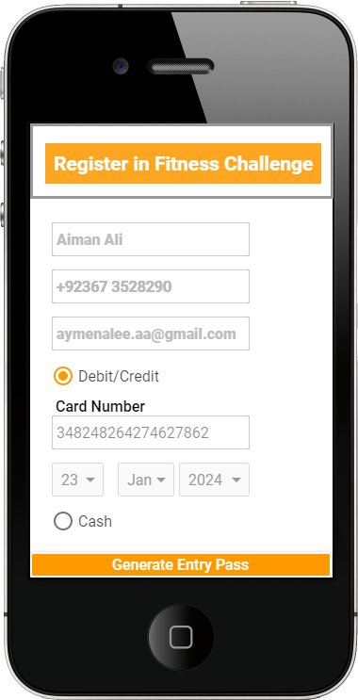 **5 6**

‘

**7**

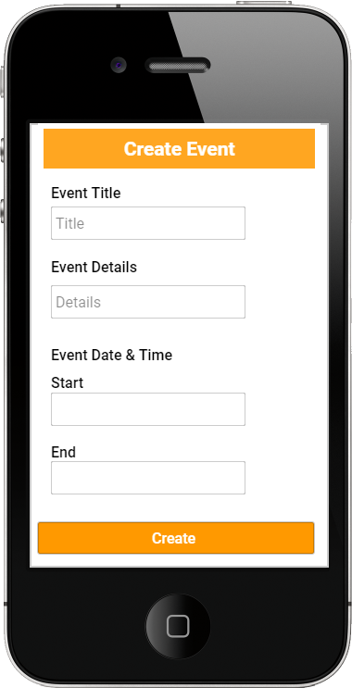

1. **People with difficulty using keyboard**

They simply use QR code scan or invite Code to register in the event basically such type of icons we use to make easy for people to use app easily and learnable and memorable for them

1. **People with visual disability.**

The color are simply black, white, orange and grey which is easy visible to people who have different types of blindness red, green, monochrome, yellow etc.

1. **People who are more than 45 years old.**

The interfaces are simple, with the use of icons and less text to ensure the user who do not understand technology will be able to understand that how to use this app.